**Tutorial No. 1**

**Basics of HTML and CSS- Table, List, Image, Hyperlink, Class and ID, HTML5 Audio tag, Video tag**

**Batch: Roll No.: Tutorial No.: 2**

**Aim: Basics of HTML and CSS- Table, List, Image, Hyperlink, Class and**

**ID, HTML5 Audio tag, Video tag**

**___________________________________________________________________________**

**Resources needed: HTML Editor/Notepad ++**

**___________________________________________________________________________**

**Theory:**

* **HTML (HyperText Markup Language).** This language specifies the *structure* and *content* of a web page. You can think of it as the flesh and bones of a site.
* 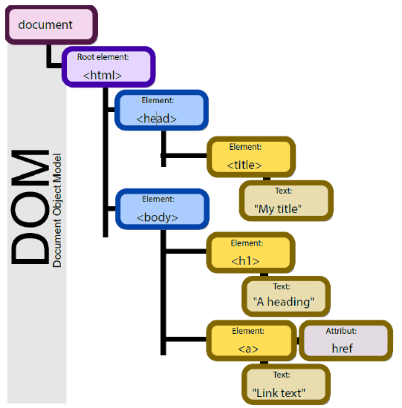**CSS (Cascading Style Sheets).** This language specifies the *appearance*, *presentation* or *style* of a web page. You can think of it as the clothes, though sometimes the metaphor of skin is used.

The DOM is built to be language and platform independent so any software or programming language can use it to interface with documents. It defines the interface methods and  
object types that represent elements of documents, the semantics and behavior of attributes of those objects, and also defines how they relate to one another. The DOM, effectively, is what gives rise to the tags we are about to study below. Languages that use the DOM, however, are not required to include all of its features and may generate additional features of their own.

Figure above depicts an example of a document’s model in a tree format, with nested elements appearing to the right and below their parents. In this example, we are shown an HTML page with a section for the head and the body, which includes a page title and a link as its contents. This structure provides the ability for us to traverse, or move around the document, by referring to an object’s name or attribute.

## HTML Documents:

All HTML documents must start with a document type declaration: <!DOCTYPE html>.

The HTML document itself begins with <html> and ends with </html>.

The visible part of the HTML document is between <body> and </body>.

## HTML Elements:

The HTML **element** is everything from the start tag to the end tag:

<tagname>Content goes here...</tagname>

**HTML Attributes**

* All HTML elements can have **attributes**
* Attributes provide **additional information** about elements
* Attributes are always specified in **the start tag**
* Attributes usually come in name/value pairs like: **name="value"**

**The HTML style**

The HTML style attribute is used to add styles to an element, such as color, font, size, and more.

# HTML Text Formatting:

HTML Formatting elements were designed to display special types of text:

* <b> - Bold text
* <strong> - Important text
* <i> - Italic text
* <em> - Emphasized text
* <mark> - Marked text
* <small> - Smaller text
* <del> - Deleted text
* <ins> - Inserted text
* <sub> - Subscript text
* <sup> - Superscript text

**HTML Quotation and Citation Elements**

* <abbr> -Defines an abbreviation or acronym
* <address> - Defines contact information for the author/owner of a

document

* <bdo> - Defines the text direction
* <blockquote> - Defines a section that is quoted from another source
* <cite>- Defines the title of a work
* <q> - Defines a short inline quotation

**HTML Comment Tags**

You can add comments to your HTML source by using the following syntax:

<!-- Write your comments here -->

## What is CSS?

Cascading Style Sheets (CSS) is used to format the layout of a webpage.

With CSS, you can control the color, font, the size of text, the spacing between elements, how elements are positioned and laid out, what background images or background colors are to be used, different displays for different devices and screen sizes, and much more!

## Using CSS

CSS can be added to HTML documents in 3 ways:

* **Inline** - by using the style attribute inside HTML elements
* **Internal** - by using a <style> element in the <head> section
* **External** - by using a <link> element to link to an external CSS file

The most common way to add CSS, is to keep the styles in external CSS files. However, in this tutorial we will use inline and internal styles, because this is easier to demonstrate, and easier for you to try it yourself.

**_______________________________________________________________________**

**Activity:**

**Students are required to**

1. **Tables:**

**Explore following tags and style the HTML Tables**

* Use the HTML <table> element to define a table
* Use the HTML <tr> element to define a table row
* Use the HTML <td> element to define a table data
* Use the HTML <th> element to define a table heading
* Use the HTML <caption> element to define a table caption
* Use the CSS border property to define a border
* Use the CSS border-collapse property to collapse cell borders
* Use the CSS padding property to add padding to cells
* Use the CSS text-align property to align cell text
* Use the CSS border-spacing property to set the spacing between cells
* Use the colspan attribute to make a cell span many columns
* Use the rowspan attribute to make a cell span many rows
* Use the id attribute to uniquely define one table

1. **Lists:**

**Explore following tags of HTML Lists**

* <ul> Defines an unordered list
* <ol> Defines an ordered list
* <li> Defines a list item
* <dl> Defines a description list
* <dt> Defines a term in a description list
* <dd> Describes the term in a description list

1. **Images:**

**Explore following tags of Images**

* Use the HTML <img> element to define an image
* Use the HTML src attribute to define the URL of the image
* Use the HTML alt attribute to define an alternate text for an image, if it cannot be displayed
* Use the HTML width and height attributes or the CSS width and height properties to define the size of the image
* Use the CSS float property to let the image float to the left or to the right

1. **Block and Inline Elements**

* The <div> element is a block-level and is often used as a container for other HTML elements
* The <span> element is an inline container used to mark up a part of a text, or a part of a document

1. **Class Attribute:**

**Explore the Use of class Attribute:**

Create multiple <div> elements with the same class attribute. Style all the class Elements equally using .className style definition in head section.

1. **Compare ID and Class**
2. **Use the** id**attribute to style a specific element using CSS.**
3. **Make use of Audio tag** <audio controls> **and Video tag with** controls**,** width **and** height **attributes to include media in your webpage**

**__________________________________________________________________________**

**Outcome:**

**___________________________________________________________________________**

**Conclusion:**

**___________________________________________________________________________**

**References:**

1. <https://eng.libretexts.org/Bookshelves/Computer_Science/Book%3A_Web_Development_and_Programming_(Mendez)/02%3A_Document_Makeup/2.01%3A_Markup_Languages>
2. https://www.w3schools.com/html/default.asp